**Normalization Summary Questions:**

**What is a basic rule of 1st normal form?**

A database is in first normal form if it satisfies the following conditions:

* Contains only atomic values
* There are no repeating groups

An atomic value is a value that cannot be divided.

A repeating group means that a table contains two or more columns that are closely related

**Describe some problems that may occur if data isn’t normalized? Use one of the exercises above to explain your answer.**

Database normalization, or data normalization, is a technique to organize the contents of the tables for transactional databases and data warehouses. Normalization is part of successful database design; without normalization, database systems can be inaccurate, slow, and inefficient, and they might not produce the data you expect.

When we [normalize a database](http://sqlmag.com/article/data-modeling/are-you-really-saving-anything-by-normalizing--96847), we have four goals: arranging data into logical groupings such that each group describes a small part of the whole; minimizing the amount of duplicate data stored in a database; organizing the data such that, when you modify it, you make the change in only one place; and building a database in which you can access and manipulate the data quickly and efficiently without compromising the integrity of the data in storage.

**What is a functional dependency?**

Functional dependency (FD) is a set of constraints between two attributes in a relation. Functional dependency says that if two tuples have same values for attributes A1, A2,..., An, then those two tuples must have to have same values for attributes B1, B2, ..., Bn.

Functional dependency is represented by an arrow sign (→) that is, X→Y, where X functionally determines Y. The left-hand side attributes determine the values of attributes on the right-hand side.

**What is a transitive dependency?**

Transitive Dependencies means if we have a primary key A and a non-key domain B and C where C is more dependent on B than A and B is directly dependent on A, then C can be considered transitively dependent on A.

Another way to look at it is a bit like a stepping stone across a river. If we consider the primary key A to be the far bank of the river and our non-key domain C to be our current location, in order to get to A, our primary key, we need to step on a stepping stone B, another non-key domain, to help us get there. Of course we could jump directly from C to A, but it is easier, and we are less likely to fall in, if we use our stepping stone B. Therefore current location C is transitively dependent on A through our stepping stone B.

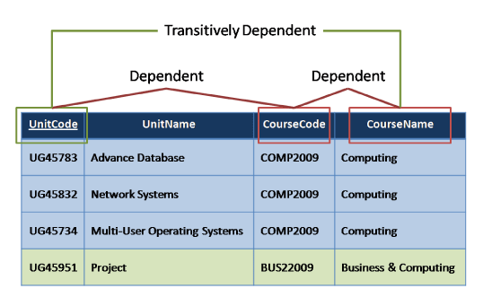

**What is a primary key?**

A primary key, also called a primary keyword, is a key in a relational database that is unique for each record. It is a unique identifier, such as a driver license number, telephone number (including area code), or vehicle identification number (VIN). A relational database must always have one and only one primary key.

**What is a foreign key?**

A FOREIGN KEY in one table points to a PRIMARY KEY in another table.

Let's illustrate the foreign key with an example. Look at the following two tables:

The "Persons" table:

|  |  |  |  |  |
| --- | --- | --- | --- | --- |
| **P_Id** | **LastName** | **FirstName** | **Address** | **City** |
| 1 | Hansen | Ola | Timoteivn 10 | Sandnes |
| 2 | Svendson | Tove | Borgvn 23 | Sandnes |
| 3 | Pettersen | Kari | Storgt 20 | Stavanger |

The "Orders" table:

|  |  |  |
| --- | --- | --- |
| **O_Id** | **OrderNo** | **P_Id** |
| 1 | 77895 | 3 |
| 2 | 44678 | 3 |
| 3 | 22456 | 2 |
| 4 | 24562 | 1 |

Note that the "P_Id" column in the "Orders" table points to the "P_Id" column in the "Persons" table.

The "P_Id" column in the "Persons" table is the PRIMARY KEY in the "Persons" table.

The "P_Id" column in the "Orders" table is a FOREIGN KEY in the "Orders" table.

The FOREIGN KEY constraint is used to prevent actions that would destroy links between tables.

The FOREIGN KEY constraint also prevents invalid data from being inserted into the foreign key column, because it has to be one of the values contained in the table it points to.